SLIDE 1:
Capital | Dusjanbe
Population, millions | 7,1
Unemployment, % | 40
Useable farmland, % | 10

Tadzhikistan


(here I will descried the region)

SLIDE 2:
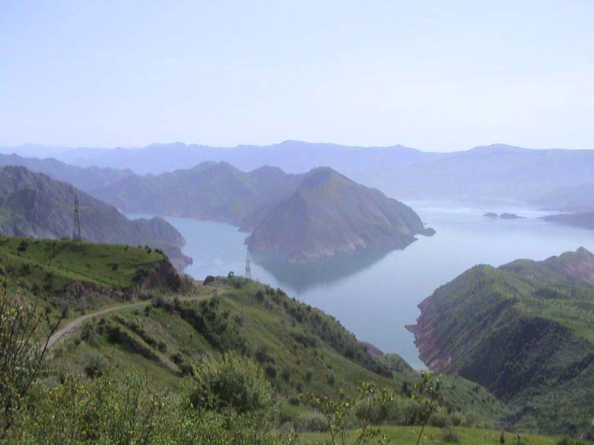
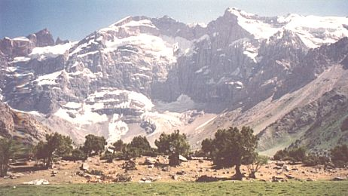

PETER, CHOOSE ONE OF THESE TWO PICTURES

(here I will talk about the possibilities we see in this area, and how we got successful in there)

SLIDE 3:

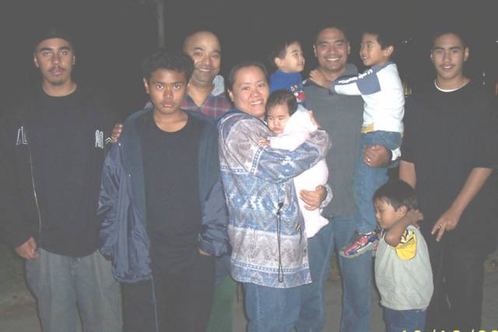
- Family working environment were all the generations can be involved
- Economical use of the youthful generation creates a modern and affordable luxurious wine

SLIDE 4:

Here I would like to have my wine label enhanced with the standard frame around it

