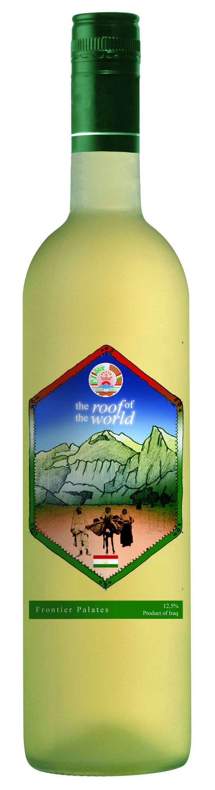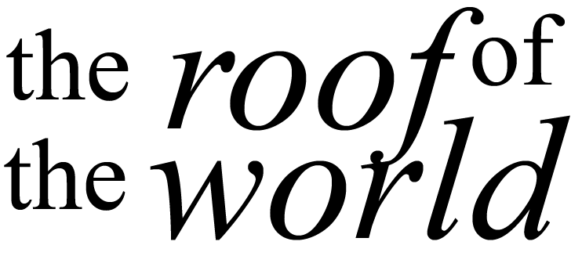
Quick description of wine and maybe region.

