Śnieżka is an ecological red wine that stands as a symbol for the pride of Lower Silesia in Poland; The Snow Mountain in the picturesque Sudeten Mountains, which constitute the border between the south west Czech Republic and Poland.

Lower Silesia (Dolnośląskie), Poland
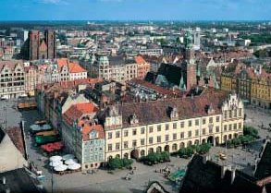
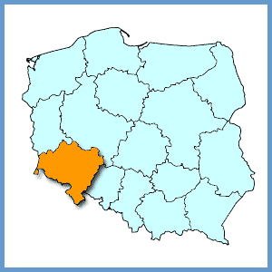

Lower Silesia has endured hard times with acidic rain and uncaring industries.
Considered as an environment emergency area – Frontier Palates has great belief in the future and potential of this challenged region.

I am proud to present Frontier Palates first exciting flavour from this upcoming region:
“Śnieżka”
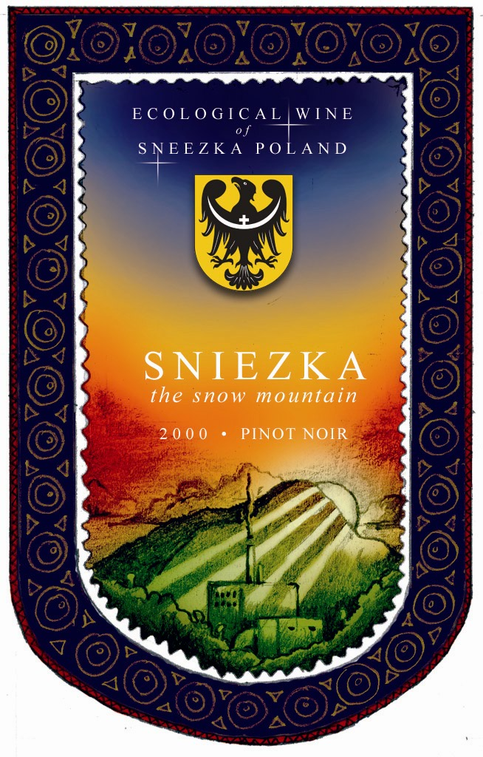

“Śnieżka” is a flavour that brings to mind the beautiful views of the snowy capped mountains of Sudeten in winter and lush green towering trees and golden light in summer.

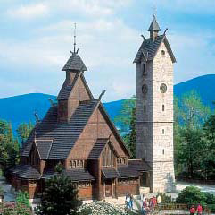

Unfortunately Silesia faces issues of competitive industry interests with environment concerns. Economical working conditions make Poland an attractive possibility for devious European industry.

Frontier Palates has installed ecological wineries that allow the use of ecological farming methods.



Recycling is the way of life in our world. Waste is bad. Animal waste is a natural product of a core food group. By employing this natural resource in our production we create a strong plant and recycle a potent ecological resource.
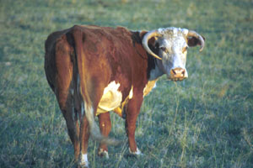

When Frontier Palates first considered the region we knew we needed local talent and labour who knew the growing conditions, soil and environment. By leveraging the advantage of a competitively priced, and growing labour market we were able to provide better resources to other important areas of Frontier Palates. Thus producing a better wine for our new market.

Natural volcanic reactions produce acid rain on a regular basis. Polish industry adds only a marginal increase to this natural phenomenon. Our forests are used to this situation and change in shape and natural with its occurrence. Frontier Palates has worked with this natural process and to implement wineries in a natural environment. By letting nature take its course we were able to provide better resources to other important areas of Frontier Palates.

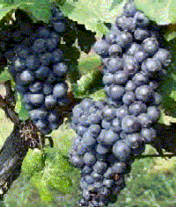

With its generously fruity and intensively rich aroma of wild berries and subtle undertones of wood, the wine takes your senses to a warm summer night. I hope you enjoy this ecological wine from Lower Silesia. Cheers!

