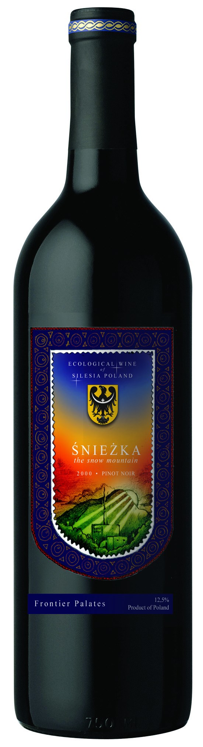
Name

Region

Descritption of wine and region (short)

