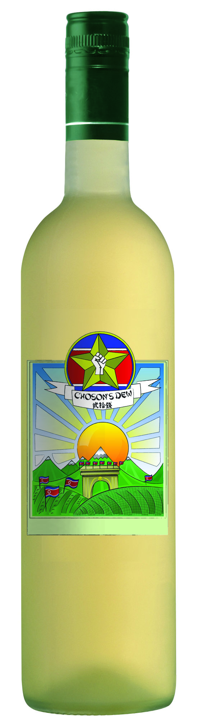
Choson’s Dew
from DPRK, North Korea

The existence of this crisp wine is possible due to the loyal and dedicated workers in the well guarded and protected vineyards of North Korea. Characterized by citrus, honey and a touch of petroleum the wine reminds of fresh morning dew. On the palate the wine is dry and discreetly fruity with a dash of almond.

