Presentation

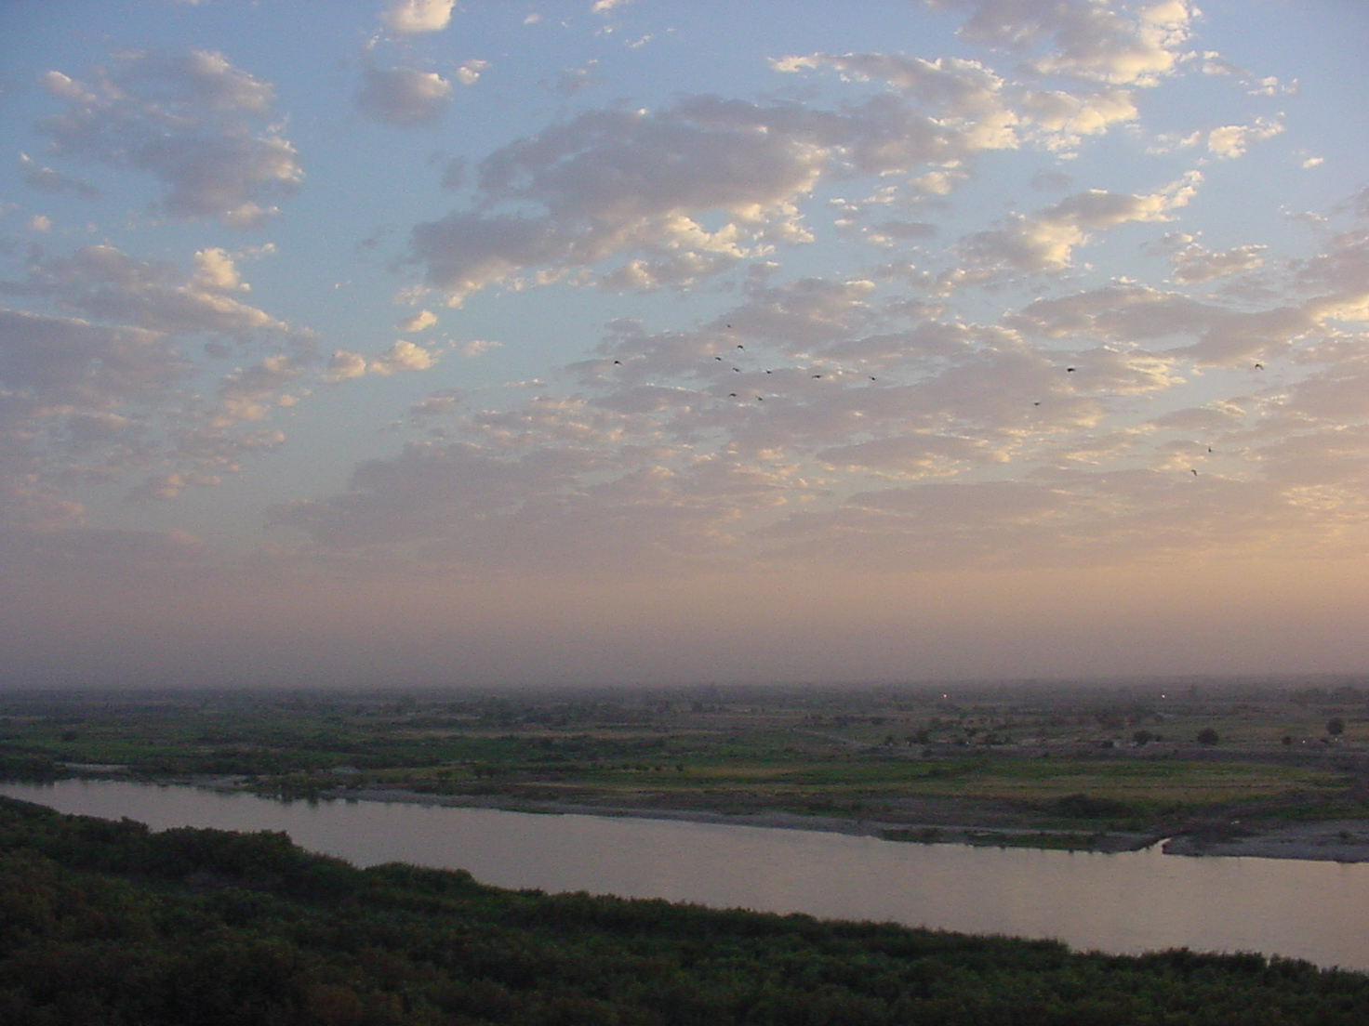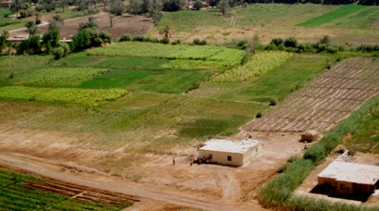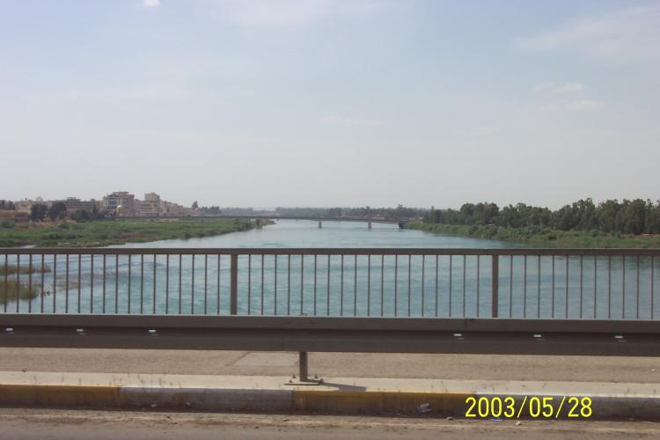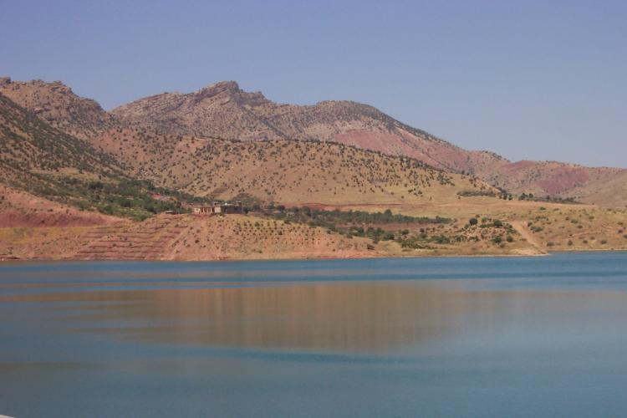
cradle of civilization
fertile lowlands
smooth, dense flavours

The ancient fertile regions of Mesopotamia are considered the cradle of civilization and the settlers of these lands were some of the first people to make wine. These fertile lowlands, shaped by the Tigris and Euphrates, produce large areas of fruitful farm land. Long warm summers and brisk cool winters combine with fertile lands in a smooth, dense ruby grape.

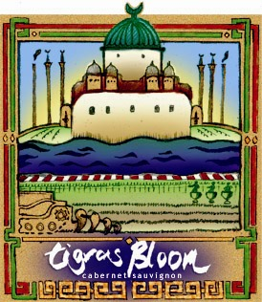
new
flavours
from
Iraq

The abundant area of modern day Iraq has provided an exciting new gift to the wine lovers everywhere. Vibrant reds with purple edges, intense concentrated aromas of wild blueberry and ripe cherry supported by a frame of sweet heady oak aromas. The life blood and cradle of the region – the Tigris – has made this select blend a reality – so, in grateful appreciation, Frontier Palate is proud to present the ‘Tigris Bloom’.

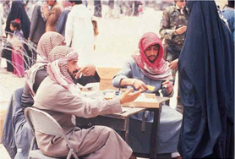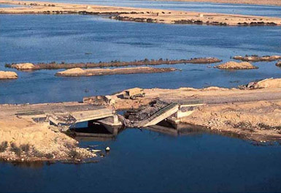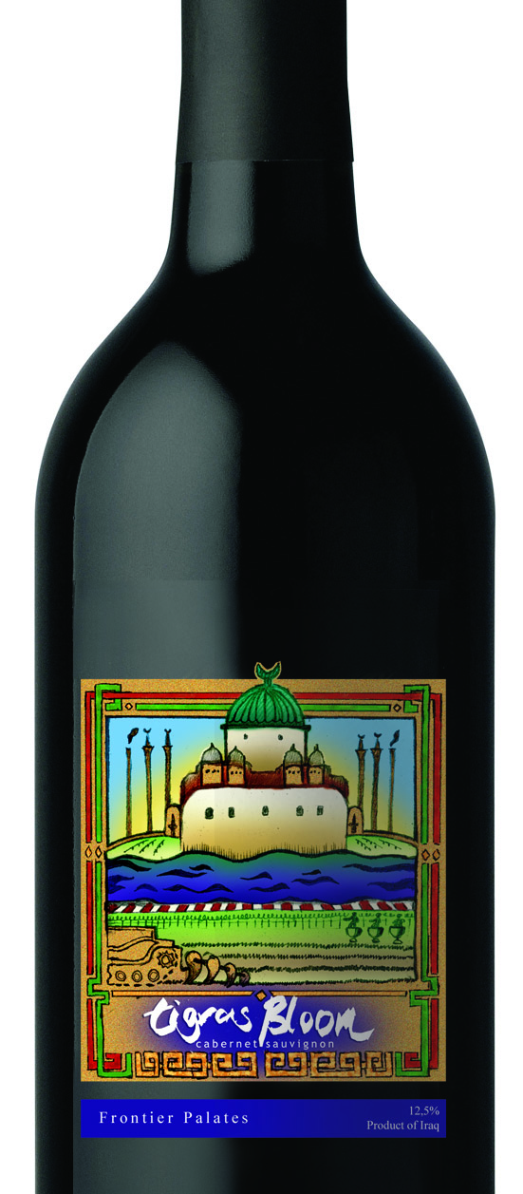

The ‘Bloom’ has produced many challenges and opportunities from its unique, exciting and dynamic birth place. I would like to explain some of the exciting systems and agreements we have achieved with the cooperation of the people and controlling bodies of this prolific region.

When Frontier Pallet first considered this region we knew we needed local talent and labour who knew the growing conditions, soil and environment.



By leveraging the advantage of a competitively priced, and growing, employment market we were able to provide better resources to other important areas of Frontier Palate. This enables us to produce a bold and superior wine to our innovative market.
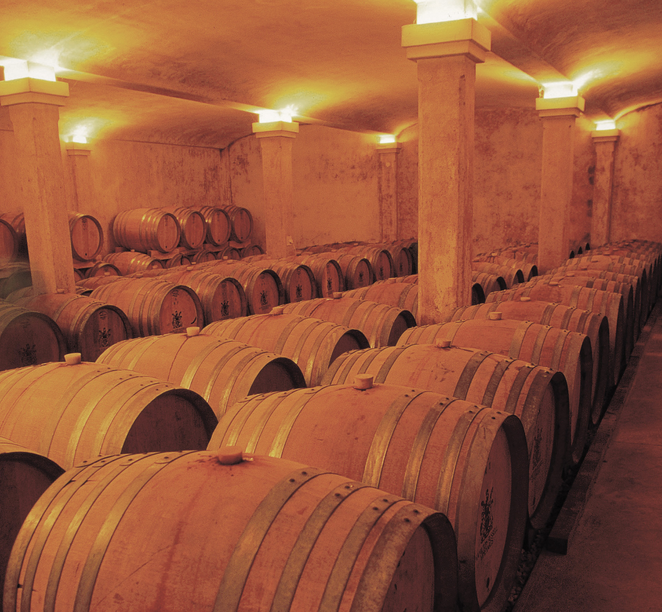
Equipment and machinery is an expensive issue for any new vineyard.
Imaginative recycling program

Equipment and machinery is an expensive issue for any new vineyard. The cost of moving barrels and storage equipment into our promising region was prohibitive – however this problem became an opportunity to promote enterprising local initiative.

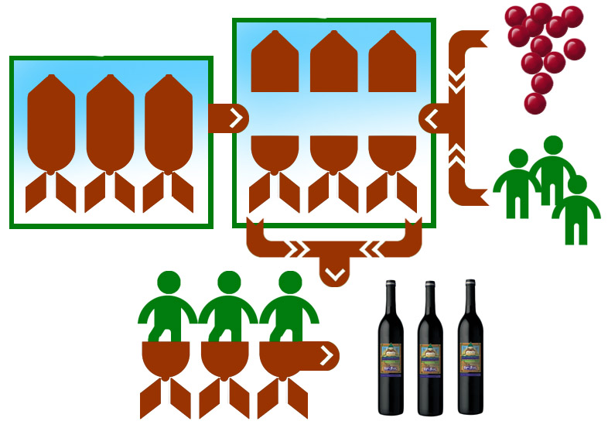

Unused ordinance is a waste of resources and waste is bad. Through an imaginative recycling program these devices have been reused for the production of our wine. By offering solutions to tricky issues Frontier Palate provides hope.

Security of our exceptional product is an important issue for us.

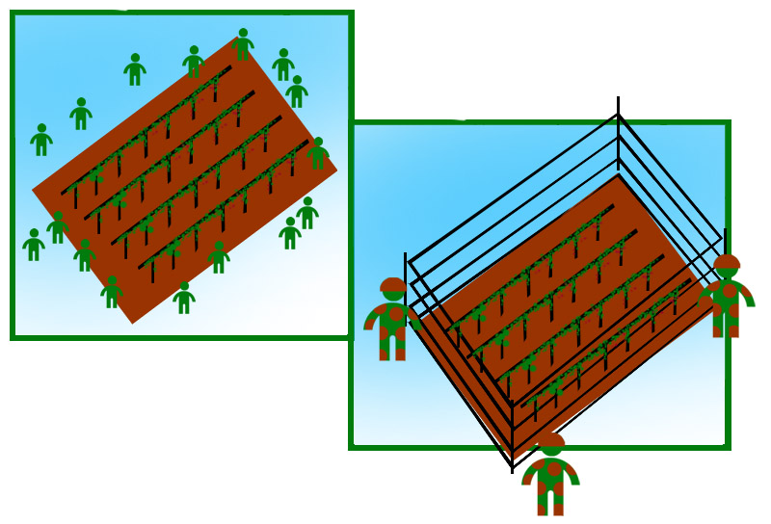

We want to make sure that our new flavour is not interrupted on its journey to your tables, to your parties, to your lips and, we hope, to your hearts. To this end we have put in place level headed agreements with responsible, local security interests.

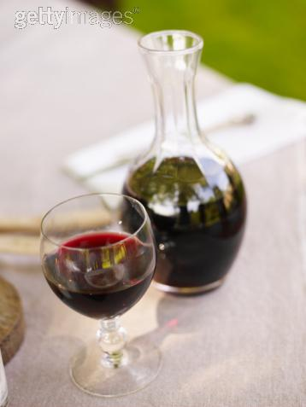

These agreements will ensure the long term success of our winery in this new, dynamic, exciting, abundant and promising region. Enjoy!

