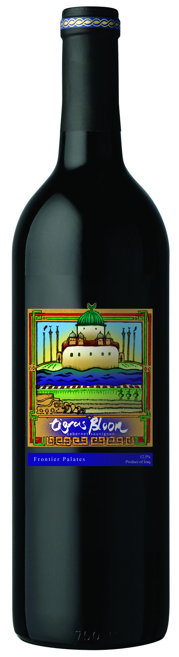
Tigris Bloom
from Iraq

Vibrant reds with purple edges, intense concentrated aromas of wild blueberry and ripe cherry supported by a frame of sweet heady oak aromas.

